

CLIENT: | Thelen CDJR | PHONE #:
SPOT: | THEL-CD-T200902 Sept Ram Power | FAX # : | Sept Ram Spot
LENGTH: | :30 | SALES REP: | Larry H.
DATE: | 9/9/2020 | PRODUCER | A. Dennis

GRAPHICS | Video | AUDIO
Thelen Chrysler Logo  Euclid Ave. - Bay City  www.thelenchryslerjeepdodge.com  (Chrysler, Dodge, Jeep, Ram Logos)  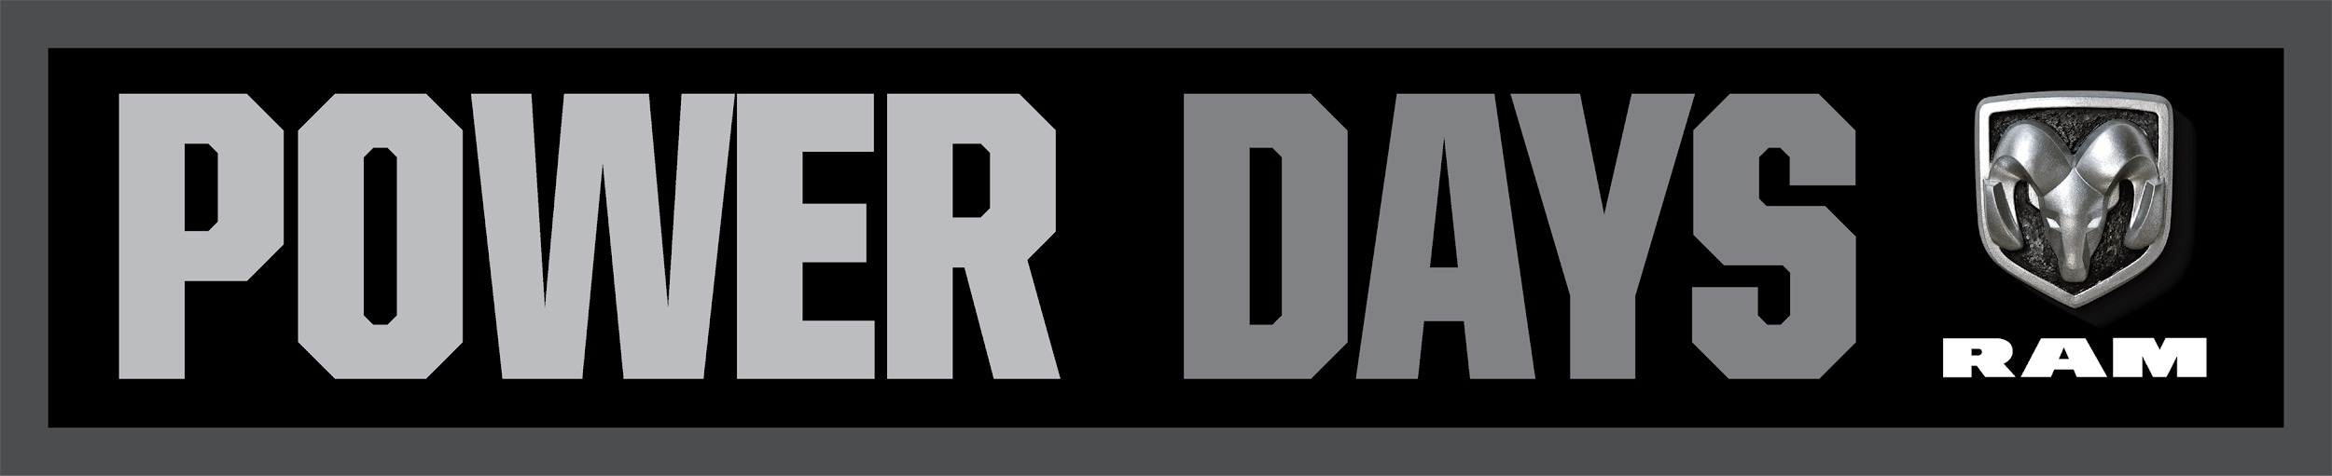  2020 Ram 1500 Big Horn Quad Cab  Lease From Just $179 /mo  Or Choose  0% APR For 72 Months  Lease for 42 months, 10,000 miles per year for qualified lessees with approved credit. $3,172 due at signing, taxes extra. Limited to availability in stock. Must qualify for Chrysler Employee Pricing and all available incentives and rebates. 0% APR for 72 months equals $13.89 per $1,000 finananced, regardless of down payment. For well qualified buyers with approved credit through Chrysler Capital. Cannot be combined with some other offers and incentives. Not all buyers will qualify. See Thelen Chrysler for details. Ends September 30, 2020.  Thelen Chrysler Logo  Euclid Ave. - Bay City  www.thelenchryslerjeepdodge.com  (Chrysler, Dodge, Jeep, Ram Logos) | GFX: 2020 Ram Power Days Logo  GFX: 2020 Ram 1500 Big Horn Crew Cab | Announcer: (:)  Thinking about a new Truck? Then Think Thelen Chrysler Dodge Jeep Ram in Bay City!  You need a new truck. And Thelen Chrysler is here to help!  We’ll find or customize a new Ram Truck with the options you need, plus a low payment!  And during Ram Power days, lease a new Ram 1500 Big Horn from just $179 a month! Or choose 0% APR for 72 Months!  So Think Thelen Chrysler Dodge Jeep Ram - Euclid avenue, Bay City!  Helping you find the right truck... because it’s the right thing to do!
Approved:_______ Approved with Changes: Client Signature: _________________________________

